EnerTech is the application of the Technology to the Energy sector. It is another aspect of the Fintech Industry. The solar photovoltaic is an emerging area of Energy. A photovoltaic (PV) is the conversion of sunlight into DC electricity using solar cells. A PV system utilizes solar or PV modules, an assembly of solar cells. When the solar energy is absorbed by a solar module, it is converted partly into **thermal energy** and partly into **electrical energy**. That means the cell and overall module temperature will increase while producing electricity. Thus, the temperature of the solar device has an adverse effect on the electricity generation. The solar module temperature is a design characteristic of the device. As the sun shines on the module, it shall not heat up too much. When modeling the performance of a solar system, the module temperature must be measured; which is not easy considering all the meteorological variations. So, the nominal operating cell temperature (NOCT) was defined. Let’s say that you did your research and found different solar panels with the same rated power that you need. So, other than the manufacturer’s reputation, how could you tell which one is better? NOCT will help you to choose the PV panel that will perform better. The overall temperature of the module will seriously affect its peak power. Insurer, bankers, and other financial institutions use NOCT to estimate the expected performance of the solar system as part of determining high-quality products. State agencies such as the California Energy Commission (CEC) uses NOCT to estimate nominal output power of photovoltaic modules in order to calculate the appropriate incentive level.

The problem is that the current procedure for calculating the NOCT does not guarantee repeatable results. Our aim is to develop a tool for processing solar data and determining NOCT values using linear regression and other machine learning techniques; and compare to existing procedure. Data are available on multiple solar modules and in different seasons and for multiple years; making it easier to test the repeatability (consistency) of the results.

NOCT is defined as the cell temperature of an open circuit PV module under the conditions below:

Ambient temperature: 20 degC

Solar Irradiance: 1000 W/m2

Wind Speed: 1 m/s

Solar manufacturers include the following thermal characteristics in the spec sheet of a PV panel:

NOCT: e.g. 47.5 degC

Temperature coefficient Pmax: -0.485%/degC

How to use NOCT to choose a solar panel?

NOCT will help choose the PV panel that will perform better and will give more power once installed. The overall temperature of the module will seriously affect its peak power. So to estimate a more realistic value, we have to calculate the module power losses under operational conditions.

For example, let’s say we have a panel with the following characteristics:

Max power at STC: 240 W

NOCT: 47.5 degC

Temp coeff of Pmax: -0.484%/decC

The power losses will be:

Power Losses (%) = Temp coeff x (NOCT – 25) = 10.91%

That means we lose at least 10.91% of the rated power when we start actually using the PV panel. In other words, the max power we can expect from this panel is about 213 W.

Smaller NOCT = Less Power Losses

A more realistic measure of PV output is the PVUSA Test Conditions or PTC rating. PTC actually stands for Photovoltaics for Utility Scale Applications Test Conditions. These conditions were developed to test and compare PV systems as part of the PVUSA project.

The PTC rating is lower than the nameplate rating and reflect better the "real-world" solar and climatic conditions, compared to the nameplate rating, which is STC rating.

In the state of California, PV system components for building, such as PV panels, must be certified through the California Energy Commission’s (CEC) PV system certification program. And they require rating panels using PTC. The CEC’s PV module list can be found on the Go Solar California website: https://solarequipment.energy.ca.gov/Home/PVModuleList

PTC Calculation Inputs

Pmax at STC

NOCT

gamma (Temp coeff of Pmax)

Total module area

PTC Ratings

Efficiency

Module Temperature at PTC

Pmax at PTC

Calculating Module Temperature at PTC:

see paper “*NOCT to PTC conversion equations from CWhitaker*”

Calculating Pmax at PTC

Pmax at PTC = Pmax@STC * (1 + (gamma/100)*(Tmodule@PTC – 25))

NOCT vs ROI

Payback time calculation

Savings after tax credit = cost of solar panel x tax credit

Initial investment = cost of solar panel – savings after tax credit = cost_of_solar_panel*(1-tax credit)

break_even = initial_investment / (avge_monthly_electricity_bill*12)

Example

Tax credit = 30%

Cost of panel = 25,000

Yearly_electricity_bill = 1,200

Initial_investment = (1-0.3)*25,000 = 17,500

break_even= 17,500/1,200 = 14.6 years

Average Cost of solar panels per EnergySage (https://www.energysage.com/local-data/solar-panel-cost/)

California: $2.86/Watt 🡪 12.5% solar panels = $0.36 / Watt

Arizona: $2.44/Watt 🡪 12.5% solar panels = $0.30 / Watt

Power at STC: 120 W

Temp coeff of Pmax

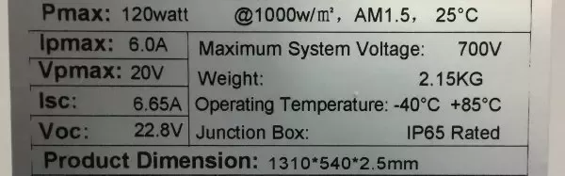

PTC rating = PVUSA Test Condition

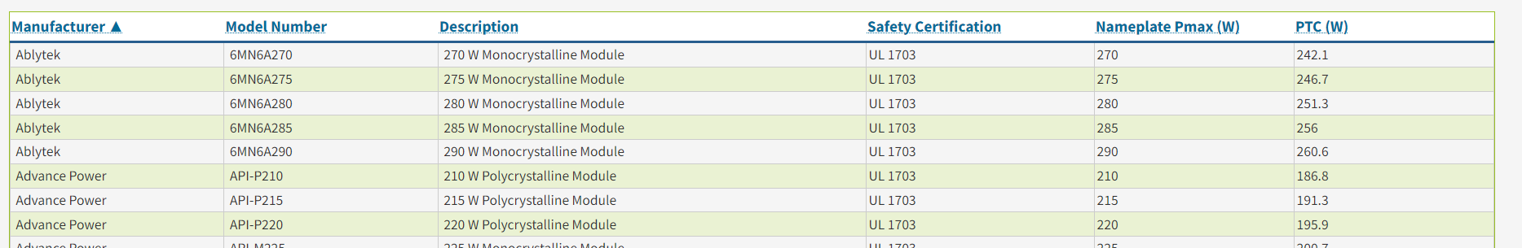

Costs before installation costs

Mono: $1 - $1.5/Watt Efficiency rate: 17% - 22%

Poly: $0.75 - $1 / Watt Efficiency rate: 15% - 17%

Thin film: $0.75 - $1.1 / Watt Efficiency: 10% – 13%

Federal solar tax credit thru 2032: 30%

According to the US Department of Energy (<https://www.energy.gov/eere/solar/solar-soft-costs-basics>), soft costs or non-hardware costs make up 65% of the total solar costs.

WhatNextNow (<https://www.whatnextnow.com/home/solar/cost-of-solar-panels>) provides a breakdown of a 2017 costs per watt of solar panels, including soft cost and hardware costs. It shows that the solar panels make up about 12.5% of the total costs. This is confirmed by a 2021 NREL study as reported by Energy Sage (https://www.energysage.com/local-data/solar-panel-cost/)

Benefits of NOCT to PV Systems

Accurate predictions of energy yield: Accurate estimate of the performance of solar modules is crucial for project planning, financing, and determining the economic viability of solar installation

System sizing and design: It ensures PV system are designed optimally, maximizing energy production and optimizing return on investment

Selection of suitable solar technologies: By comparing NOCT values among different PV technologies, one can evaluate their performance under real-world conditions and choose the most suitable option for a specific application

Long term reliability and durability evaluation: Higher operating temperatures can accelerate the degradation of PV modules over time. NOCT allows manufacturers and system owners to assess the potential impact of temperature-induced stresses on the lifespan of the solar panels

FRONT END

Navigation:

Effect on PTC

Effect on ROI

INPUTS for PTC

Module Technology

Model number

Max power at STC

Temperature coefficient of Pmax

Total module area

CEC NOCT

CEC PTC

OUTPUTS for PTC

CEC NOCT vs Fintech NOCT

CEC PTC vs Fintech PTC

INPUTS ROI

Module Technology

Model number

System size (in Watt)

Tax credit (%)

Average monthly electricity bill